Vibrant Publishing Studio - Website Content
Compiled by Drishti Sahay

About Us 2
Our Vision 2
Our Mission 2
Our Values 2
Why Vibrant? 4
Testimonials 4
Our Services 5
Content Services 5
Content Development 5
Supplement Creation 5
Alt Text Writing 5
Content Enhancement 6
Editorial Services 6
Copyediting 6
Proofreading 6
Indexing 6
Production Services 7
Typesetting 7
Content Transformation Services 7
Word, PDF, XML, HTML Conversion 7
eBook Conversion 7
Creative Services 7
Artwork Creation 7
Graphics Processing 7
Image Editing 7
Manga Studio 8
Retouching 8
Lettering 8
Scanning 8
Business Process Management 8
Web Research 8
Data Collection 8
Data Cleansing and Enrichment 8
Data Entry and Validation 8
Forms Processing 8
Contact us 8

About Us
In 2014, [x number of people] came together to offer a comprehensive suite of services to publishing houses. From basic and simple [what were the services you offered at first?] a decade ago, to today in 2024, Vibrant has expanded, in scope and complexity, to a wide portfolio of services. With our expert team, we are strategic partners to a host of global publishers and offer a wide range of services to suit every budget.
Read more about our services below:
- Content Development
- Editorial Services
- Production Services
- Content Transformation
- Creative Services
- Manga Studio
- Business Process Management
The Vibrant Future Tech Services (Vibrant) seeks to build long-term relationships with clients on the grounds of reliability, trust, and high quality service delivery.

Our Vision
“nulli secundus”
To elevate Vibrant into an unparalleled global platform for delivering exemplary value propositions to its clients, second to none.

Our Mission
To ensure happy customers and satisfied employees by leveraging innovation and creativity, advanced technology, and continuous learning and improvement.

Our Values
Our values define our organization. They serve as our guiding principles for providing top quality services and bring us closer to realizing our vision. It is important to us that our people align with our organizational values, both individually and as teams.

People
We believe that people are the backbone of any organization. Treating all stakeholders with compassion and professionally is of utmost importance to us in our operations. We uphold and are proud of our principles of mutual respect and trust, recognising and acknowledging one another's work. We encourage open lines of communication and provide avenues for personal and professional development.

Agility
Good business requires organizations to acknowledge and respond to changing circumstances while adapting innovatively. We encourage continuous learning, and undertake research to recognize, understand and tackle potential challenges to avoid circumstances that can derail a project. We are super flexible and can adapt our operations quickly to adjust to changing situations.

Teamwork
We have a flat hierarchy so as to encourage collaboration, acceptance, recognition, and appreciation as routine in our work environment. We respect and listen to one another, engage in ‘responding’ rather than ‘reacting’, and resolve conflicts via healthy dialogue. Collaboration extends beyond just our internal teams, it is how we work with our clients as well.

Integrity
Working with content needs a high standard of integrity in terms of quality, intellectual property rights and confidentiality. We place great emphasis on these points not only through our contracts and MoUs, but also on the ground where we ensure high confidentiality and ethics among our employees. Each person takes ownership of the task assigned to deliver services efficiently, appropriately, and ethically.

Excellence
At Vibrant, we strive for excellence in whatever we do. Through our continuous skill development programmes internally, we place great focus on quality control and hold ourselves to the highest industry standards while consistently learning and keeping up with the latest trends to be able to provide the best in class services.

Why Vibrant?
The answer is simple! We ask the right questions; we listen when you tell us what you want; and we use our professional experience and expertise to deliver brilliance.

Testimonials
Vibrant’s editing transformed my illustrations into a professional Manga and I couldn’t be happier with their services. From the basic sound labeling to the quirky lettering, the editing and proofreading processes would have been extremely difficult for me without the support of [person’s name] that made adjustments to meet my every request. Thank you so much!
Photo, name, designation
I approached Vibrant Future Tech to create a jacket cover for my graphic Manga novel. Vibrant was able to understand my vision and create the most perfect design to match my story. I really appreciate the time put in by the team to realize my ideas. They didn’t just make a great cover design but they also convinced me to get an index for my book for which I got great feedback from my readers. Thank you, Vibrant. I’m definitely coming back to you for all my future projects!.
Photo, name, designation
From my conversation with the Vibrant team, it’s highly evident that they’ve done thorough research and possess expert knowledge coupled with ample industry experience. Not only did they enhance my Manga and make it look super impressive, they also helped me understand how I can better my writing with their editing process. I have seen my book sales already going up. Vibrant is definitely my new partner of choice.
Photo, name, designation

Our Services
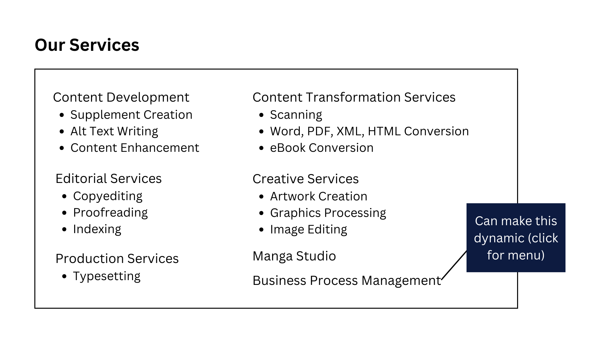

Content Services
We provide a wide variety of content services in all ranges of complexity at prices that suit your budget.

Content Development
Enhance your Manga with the large variety of Manga and Manhwa services we offer. From editing and rewriting, to enhancing your content and creating additional fun material for your fanbase and readers, we are here for you. Just give us your brief and we will make it happen!
Looking to revamp and supplement your Manga? Check out our Content Development services below.

Supplement Creation
Our team understands that fans need Canons! People love to dive deeper into the universe of characters they read about, and we recognize that. We specialize in exclusive behind-the-scenes content for your readers, ready to keep them hinged to your work as best as possible.

Alt Text Writing
Inclusion and accessibility is important to us and we believe that our differently-abled friends should be able to enjoy a story just as much as anyone else. Our team ensures quality alternative text for visually impaired readers to engage easily with your manga with the right visual cues.

Content Enhancement
We all know that content is a powerful means of communication. A stellar piece of writing is the difference between a bestseller and a book sleeping on the shelf. We have a great team that can adapt to a client’s style of writing and ideas. Each person on the team pays meticulous attention to detail and optimization of your content in order to develop captivating Manga for your readers.

Editorial Services
Grammatical errors? Sentences that are difficult to read? Written content that sounds too mechanical and doesn’t bring out the writer? NOT AT VIBRANT! We’re here to help you keep your Manga free of errors and fun to read.
Listed below are our editorial services.
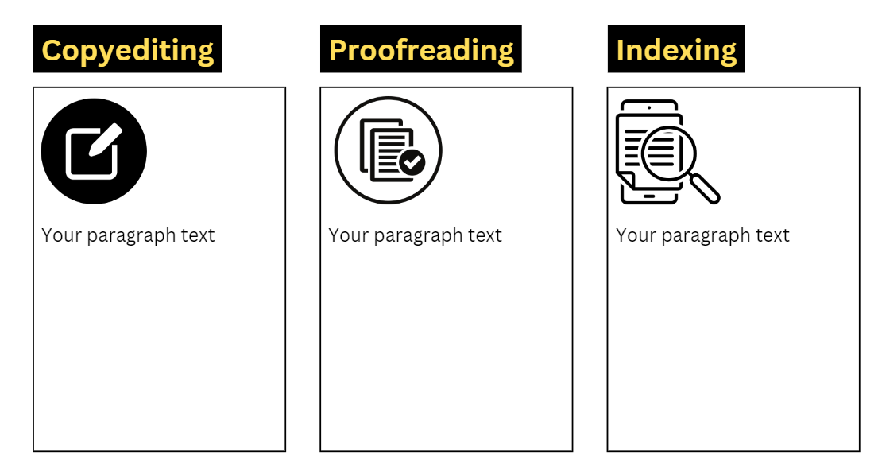

Copyediting
The transformative value of good copyediting is vital to ensure being able to bring in the writer’s voice into the story while keeping its readability and structure in place. Our copy editors are well-equipped to transform your Manga and Manhwa into ready-to-read, perfect pieces of work.

Proofreading
Vibrant’s proofreaders are meticulous and have a keen eye for detail. We make sure that your work is error-free and ready for publication with no grammatical mistakes, appropriate sentence structures, correct punctuation or any other lingering errors.

Indexing
The concept of indexing is undervalued but we understand its importance and offer the best-in-class services for you. Indexing makes it easy for readers to quickly find and navigate a specific scene or a character since there’s only so much dog-ear-ing a person can do. Our experts are capable of creating clear and intuitive indexes that can enhance your work.

Production Services

Typesetting
Typesetting is possibly one of the most sought out services in Manga. We have both the expertise as well as a vast experience in typesetting and design. We can deliver high quality design outputs optimised for print, dynamic online media, or both.
From simple and plain text to complex typesetting, including multiple column STM and intricately illustrated journals, we can provide the solution you are looking for.
Our in-house experts use the following typesetting tools.
- InDesign
- 3B2
- QuarkXpress
- Tex/LaTex
- FrameMaker
Note: We work in all roman languages.

Content Transformation Services
With the plethora of formats out there, readers and publishers have their own preferences for documents. We understand that converting from one to the other can be tiresome and time consuming and have a solution for this too.
We offer several document conversion services.

Word, PDF, XML, HTML Conversion
We offer a wide range of conversion services and can adapt our services to your requirements. Our expertise lies in preserving the formatting, structure and integrity of all your documents, when converting from Word to PDF, PDF to HTML, and so on, for both standard and specialized formats.
- MS Word Documents
- PDFs
- XML files
- HTML files

eBook Conversion
e-Books have made their way into our lives slowly but are here to stay. Vibrant specializes in converting manuscripts to eBook formats that are compatible with popular eReaders and eBook platforms, like EPUB and MOBI.
Reach out if you are looking for ways to magnify your Manga’s readership!

Creative Services

Artwork Creation
We believe that an engaging cover and jacket can take your story from sitting on a shelf right to a prospective reader very quickly. Vibrant has an expert creative team that can help you transform your design ideas into captivating visuals. We have experience designing covers and jacket art, vector images, medical illustrations, and so on. We also work on raster-to-vector images.

Graphics Processing
You know your project has done well when it looks HD in print. With Vibrant’s professional graphics processing services, we are here for you for all your graphics needs. Our team is skilled and has ample experience in enhancing existing graphics to exceptional quality and can also create new graphics as per your brief.
We believe in providing our clients with pixel-perfect content and our results reflect it.

Image Editing
When your collectors’ items or your favourite Manga novels scratch or start to fade, it is rather disheartening. With our comprehensive image editing and revitalizing services, you can trust us to breathe new life into your old images.
Our image editing services are listed below.
- Photograph Restoration
- Scratches Removal
- Colour Correction
- Contrast & Density Correction
- Colour Saturation
- Image Resizing
- Image Masking
- Image Clipping

Manga Studio

Retouching
From basic image retouching like saturation, contrast, density, colour correction, and so on, to full document enhancement to ready it for publication, Vibrant undertakes it all. All you have to do is give us your Manga project to enhance its textures, sharpen its lines, fill in the colour gaps, remove imperfections, and we hand it back to you with its original essence intact.

Lettering
Graphic novels like Manga are nothing without the right font and lettering format. Avoid losing out on readers because your lettering did not match your imagery or your story. Let Vibrant’s expert typographers craft a style for your project and carry it out for the best experience of your customers.
We hold a deep understanding of Manga conventions and strictly ensure that we integrate this understanding in all our Manga Studio work. We understand how the placement of dialogue and thought bubbles, sound effects, and narrative text boxes can change the way a story is read.
Vibrant can work with you to ensure clarity, aesthetic and the retention of YOUR voice in the story you have written, simply by enhancing the lettering style.

Scanning
Experience and skill combined with the right equipment yields magical results. Vibrant is your one-stop solution for all your scanning needs.
Our state-of-the-art scanning setup with 3 IQ smart scanners, the highest resolution flatbed scanner available in the market, ensures the retention of quality from print to digital, if not better and clearer.
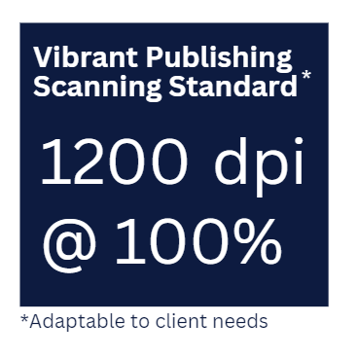

We scan full books as well as outer covers and jackets.

Business Process Management
Vibrant believes in efficient and seamless solutions, both to optimize our own operations as well as enhance our customer experience. Our business process solutions play a critical role in supporting us, furthering our verticals from the editorial and creative space to the business management space.
We provide the following services.
- Web Research
- Data Collection
- Data Cleansing and Enrichment
- Data Entry and Validation
- Forms Processing

Web Research
Our web research team can conduct comprehensive and targeted market research to understand your prospective customers better. Web research can help you to tune your product and offerings to your target audience in a manner that is most appealing to them. Our team consists of experts in market research focused on market segments, industry trends, and competitor analysis to help you gain an edge in how to market and grow your product.

Data Collection
Data collection is a foundational component of BPM for which we have in-house experts. Understanding key performance indicators and utilizing key data points in the appropriate way is central to flawless process execution. Understanding where one is going wrong optimizes workflows and maximizes efficiency. We are here to help your business soar with the right tools and techniques of data collection and analysis.

Data Cleansing and Enrichment
Most data comes with issues like gaps, duplicates, missing values and other inconsistencies. Before data can be used, it needs to be verified, cleaned and made to conform to the acceptable standards of our clients. Our team helps to ensure that data cleansing and enrichment is a continuous, dynamic process rather than a one-time incidence so as to ensure accuracy at any given point in time.

Data Entry and Validation
Our quick, complete and accurate data entry both manual and integrated automated data capture from electronic sources can be adapted to your needs. We can carry out real-time validation of your data in order to verify and ensure consistency in data types and formats, to deliver error-free results at lightning speed.

Forms Processing
Our AI capabilities can be adapted to suit your every need. Whether you’re looking for help to process physical paper forms received via mail, fax or in-person submissions, or forms filled up online, we can help you sort through everything efficiently - from the extraction and validation of data to automated processing of form data.

Contact us
Want to get in touch?
Drop a message below!
